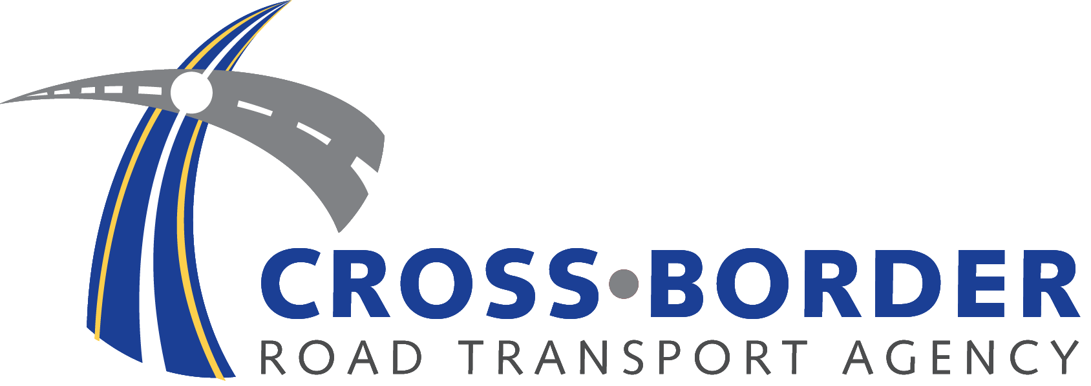

MANAGER: SUPPLY CHAIN MANAGEMENT
Ref: FIN 001/06/2021

THE EMPLOYER

The Cross-Border Road Transport Agency is a statutory authority, established in terms of Section 4 of the Cross-Border Road Transport Act, 4 of 1998, as amended, to regulate cross-border road transport.

The incumbent will have to ensure the efficiency, effectiveness, uniform planning and execution of procurement of services and goods required for the functioning of CBRTA. She/he will be required to manage the sale and letting of assets that conforms to legislative principles and preferential goals.

The position will be based at the Agency’ Head Office in Ecopark Centurion. He/she will report directly to the Senior Manager: Supply Chain Management or the Chief Financial Officer.

REQUIREMENTS:

- B. Com Supply Chain Management / National Diploma in SCM or Purchasing or equivalent
- A minimum of 5 years working experience in Supply Chain Management in the Public Sector
- Technical Knowledge of the PPPFA, PFMA, Treasury Regulations, Practice Notes, BBBEE etc.

TRAINING REQUIREMENTS
- As per National Treasury prescripts.
- Training on Supply Chain Management related courses

KEY PERFORMANCE AREAS:

The successful candidate will be expected to:

- Manage the functioning of a Demand Management System;
- Assist with the compilation of the demand and acquisition plan;
- Implement the demand management plan and assist with the budget allocation;
- Manage all prospective and approved preferred supplier list activities;
- Manage all procurement processes;
- Manage supplier performance and complaints;
- Prepare internal and external reports and ensure adequate recordkeeping methods and processes;
- Conduct internal training of SCM officials and staff on SCM policies and procedures.
- Identify problem areas and develop and apply problem solving methods.
- Implement cost reduction scheme and SCM process improvements.
- Manage contracts and lease maintenance agreements.
- Handle the steering of the bidding / tender process including reporting.

COMPETENCY REQUIREMENTS:

- Interpersonal and good communication skills (written and verbal)
- Ability to multi-task
- Ability to manage internal and external stakeholders
- Ability to manage relationships with suppliers
- Ability to manage contracts from start to end
- Good report writing skills
- Application of best SCM practice
- Ethical
- Professional

BENEFITS: The employer offers an all-inclusive market related package.

CLOSING DATE: 02 July 2021

Candidates should forward their application (CV only) to the: Human Resource Department by emailing: recruitment2@cbrta.co.za and kindly indicate the reference number.

Please refrain from submitting any supporting documents until requested to do so.

Short-listed candidates will be subjected to a reference, security clearance and criminal records check.

It is our intention to promote representivity in respect of race, gender and disability through the filling of this position. Candidates whose appointment will promote representivity will therefore receive preference.

Coloured females are encouraged to apply.

PLEASE NOTE: IF YOU DO NOT HEAR FROM US 21 DAYS AFTER THE CLOSING DATE, CONSIDER YOUR APPLICATION UNSUCCESSFUL

